**1 . BaCK BUTON ISSUE FOR ANY SECTION**

**2. THERE SHOULD BE LOGO ON EVERY SECTION WHICH WILL REDIRECT WEBSITE TO HOMEPAGE**

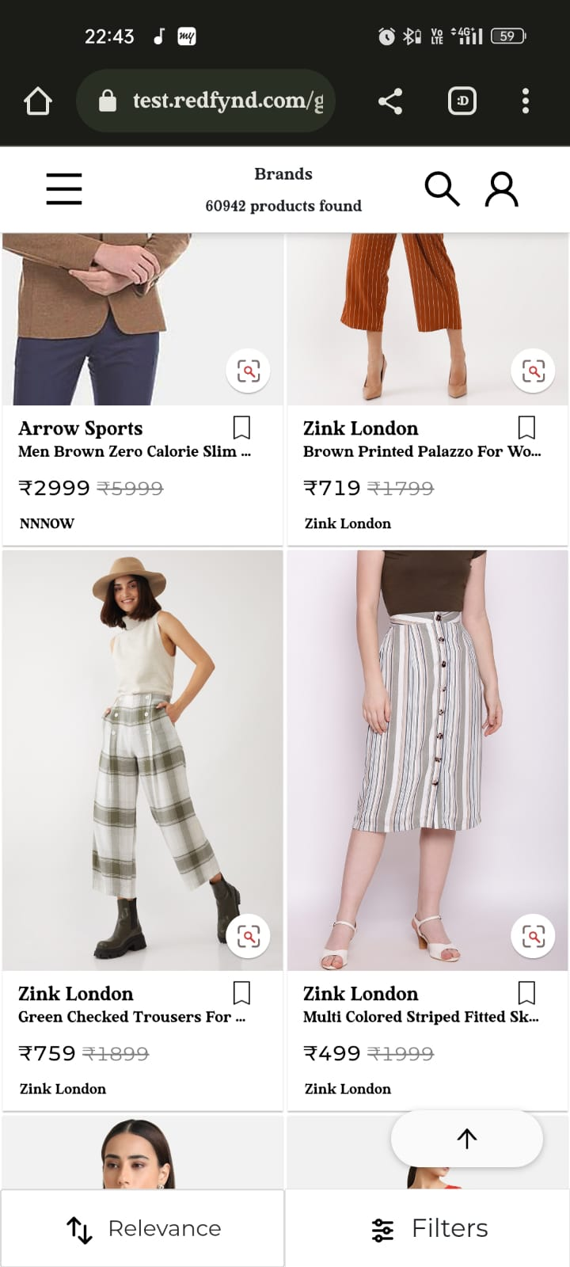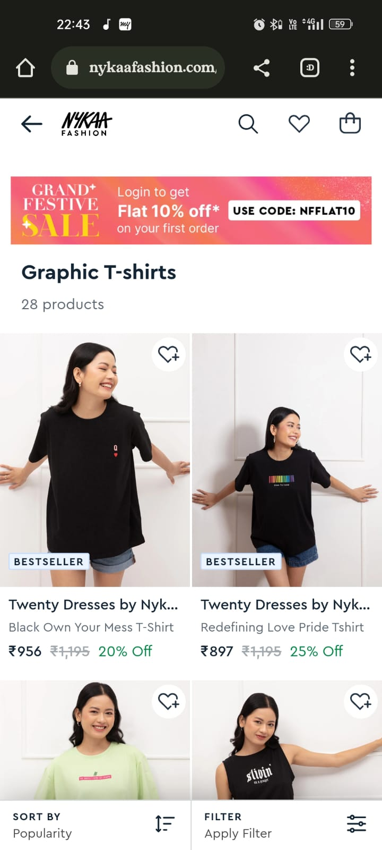

3 .Account / sign in button is not working pr

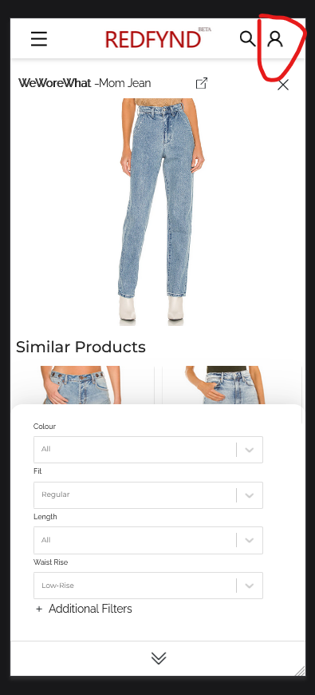

4 .Filter showing catagoty selected but having genders content . but responding correct

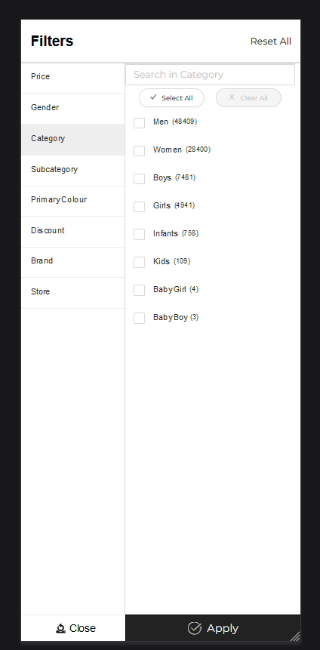

4 .Price dragger having two apply filter main one is not wroking

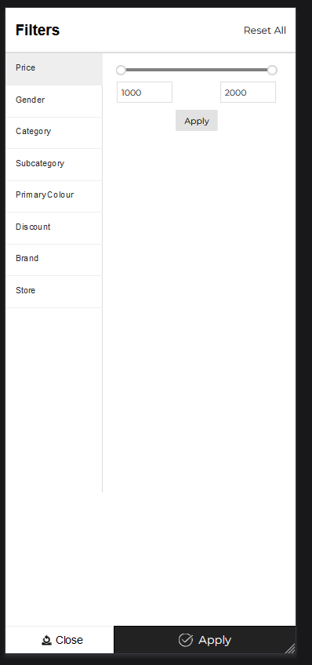

6 .Upper page arrow taking much more spaces also if page is scrolled up then it should come as a popup (reference nykaafashion)

7.Filter selected should be shown after closing the filter tab too or also indicate no of filter selected in the coloum

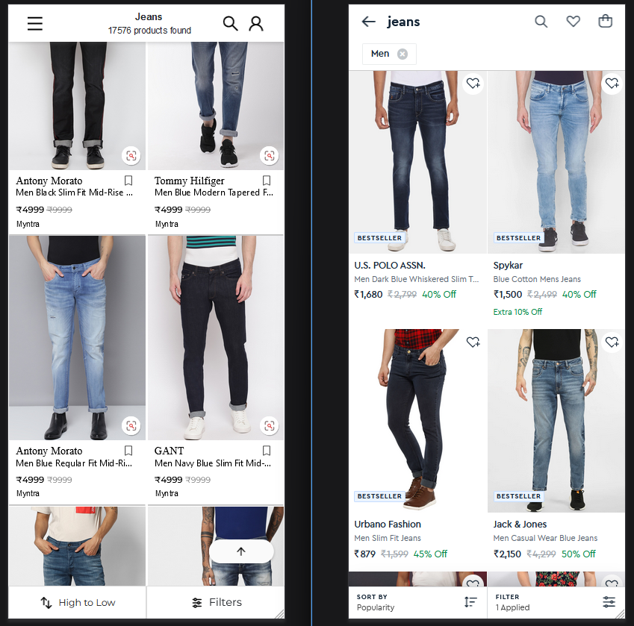

8 .search string access on keyboard

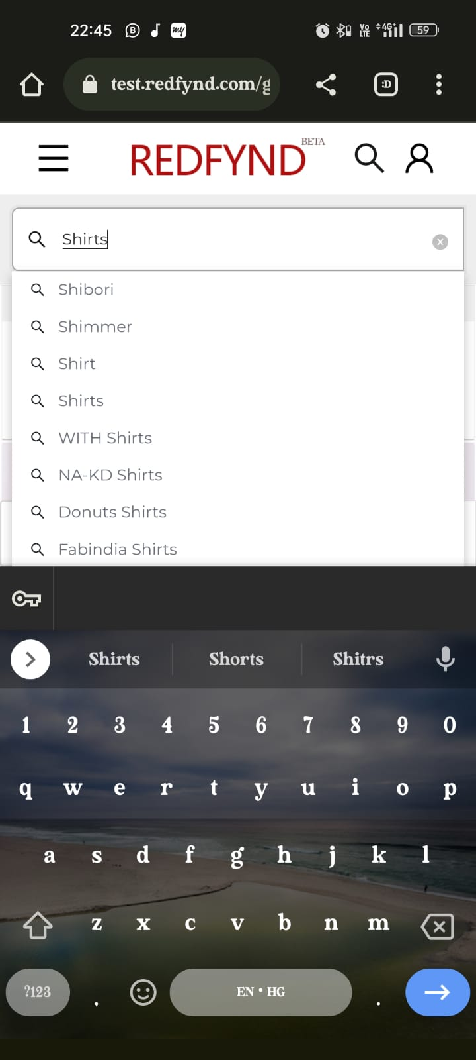

9 .Gif / amination is not working for sales

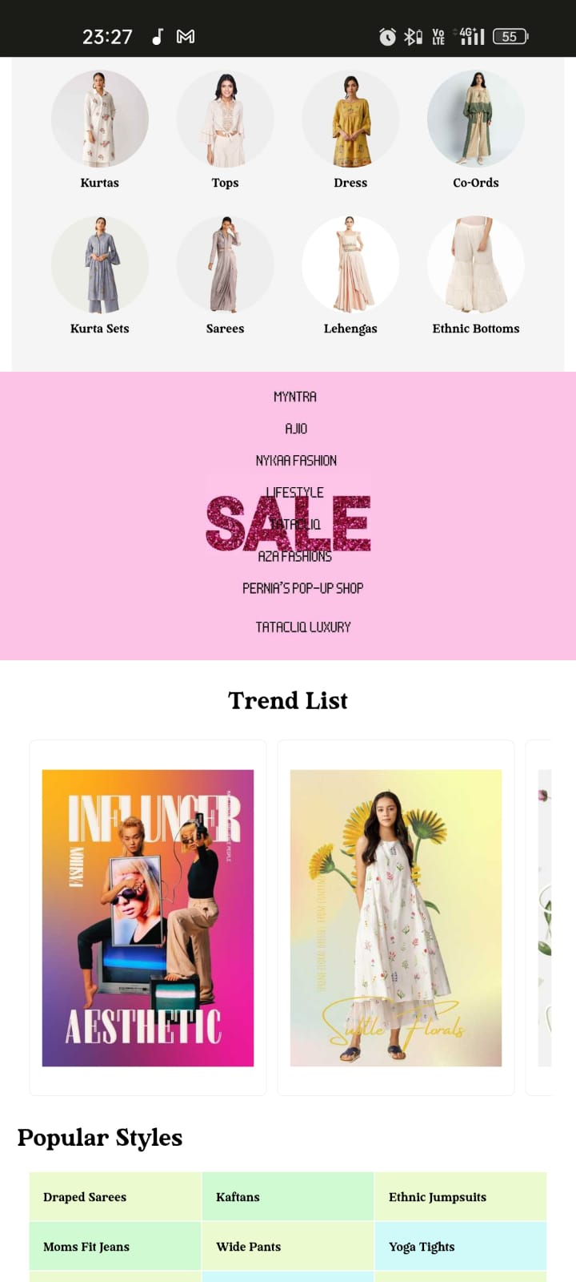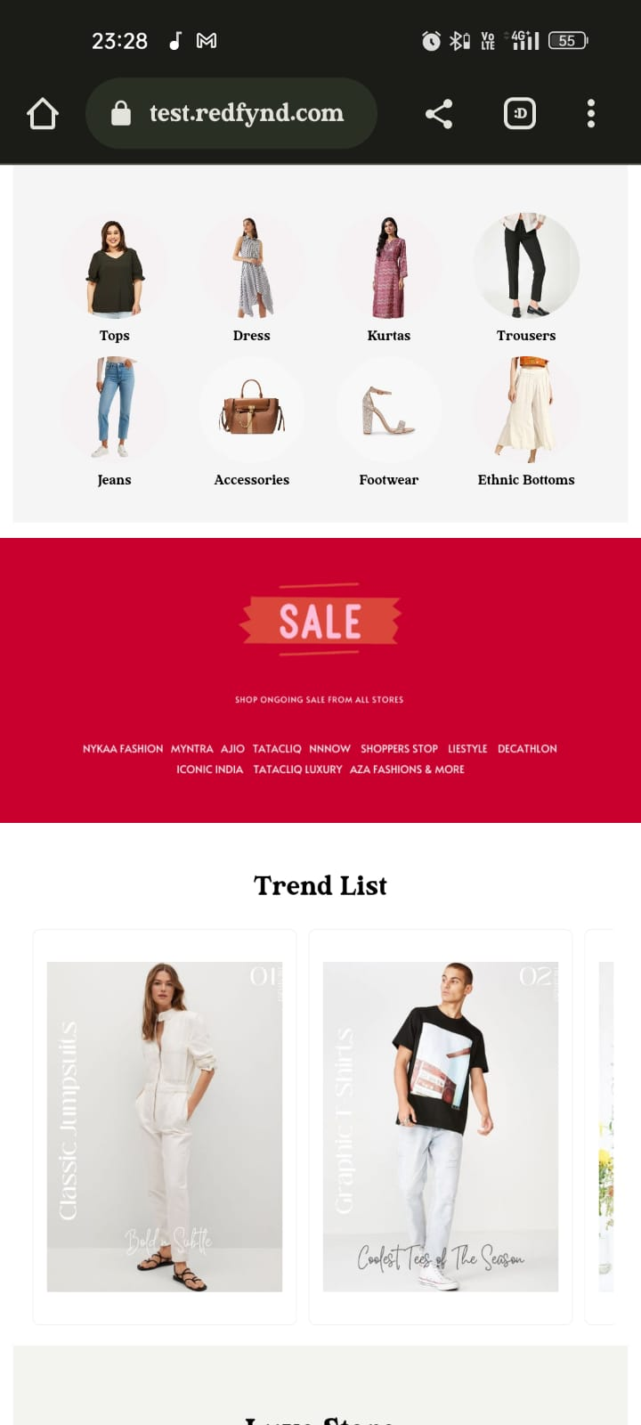

10 .All the section are not visible

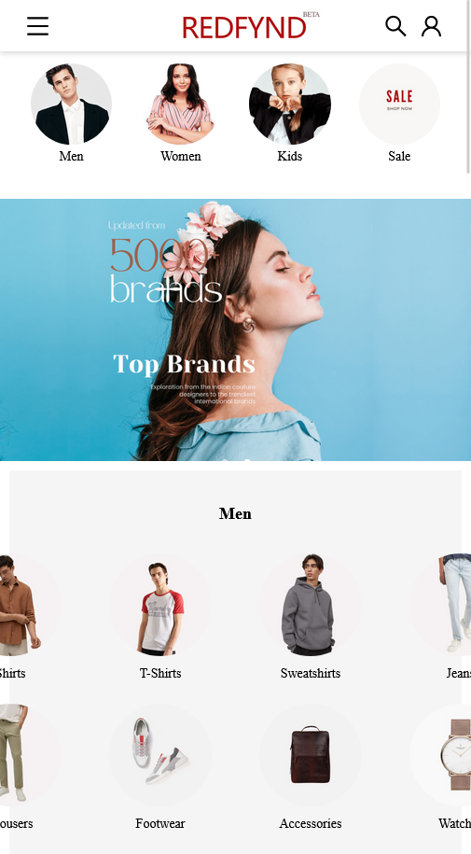

11 .Page breaking while going to banner and then clicking on refine .

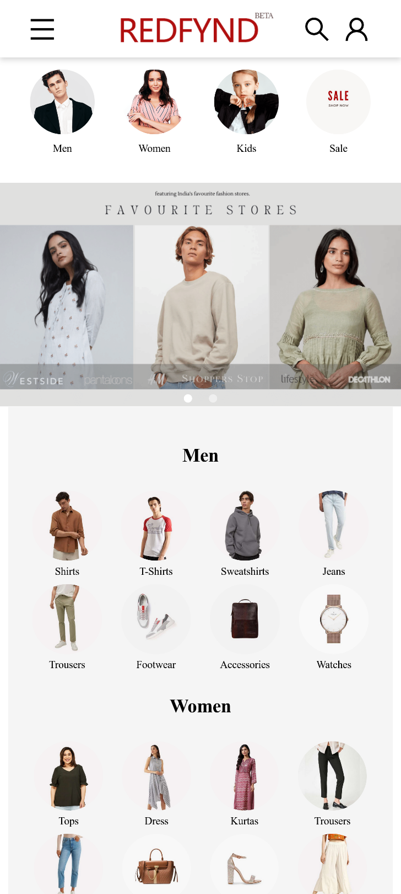



12 .Page breaking while going to banner and then clicking on refine .